**Satriyo Yudha**

**NIM:233140707111082**

**Tugas 1**

**Xamp App**

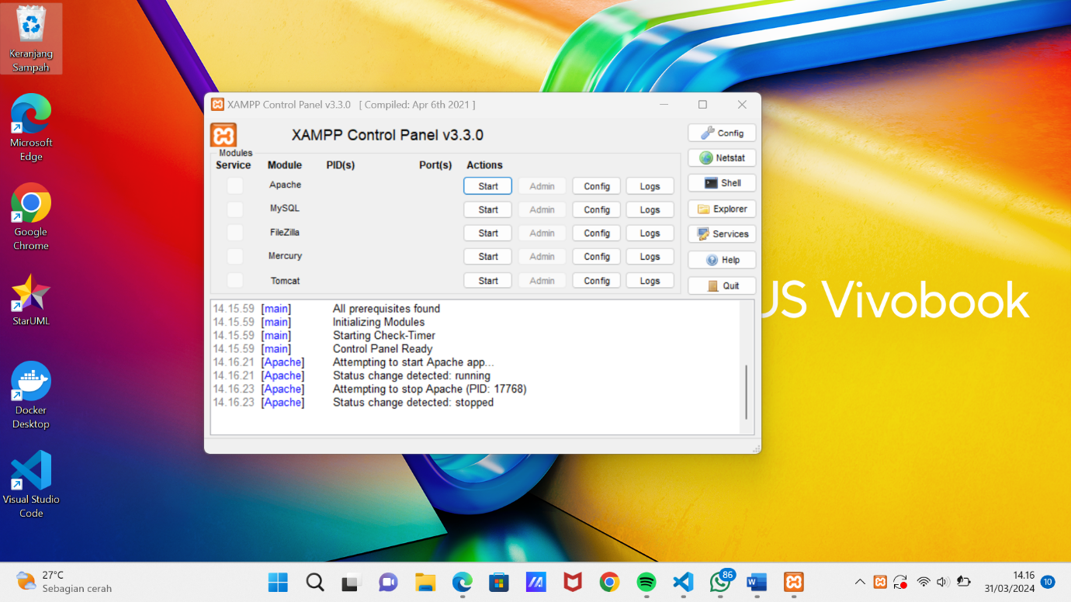

**Tampilan vs code**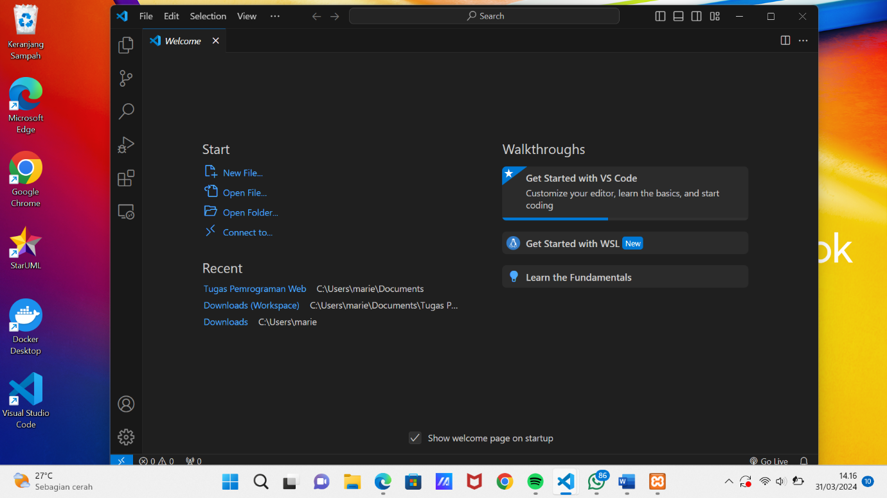

**Input Code Vs code**

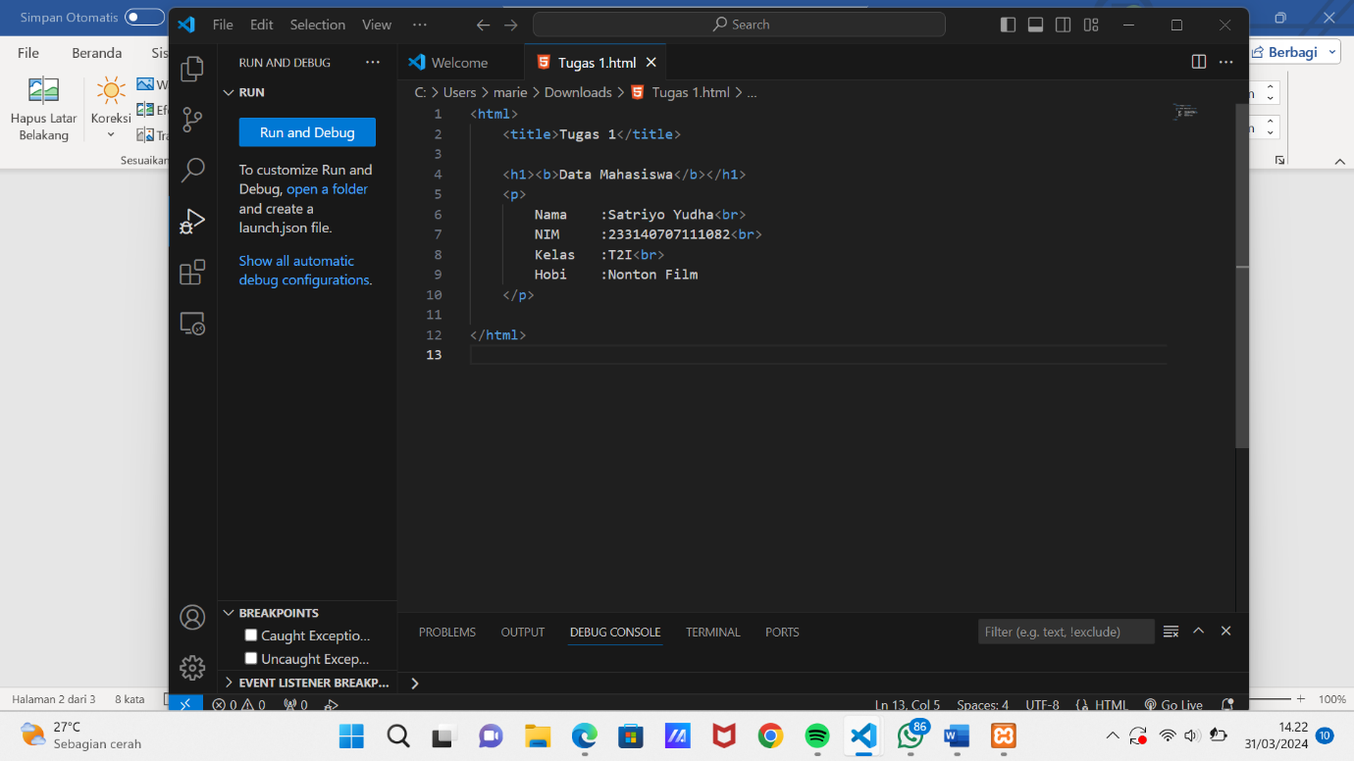

**Output Code Di atas**

